Milestone 2

1. Dataset Overview
The dataset used for this project is the India split of the RDD2022 Dataset¹. It contains 7,706 high-resolution RGB images in .jpg format, each paired with an XML annotation file stored in a separate directory.
- Rationale for RDD2022 and India Split:
  - Why RDD2022: The RDD2022 Dataset was selected for its comprehensive scope, large scale, and the variety of road damage types it contains, providing a robust foundation for a general-purpose damage detection model.
  - Why India Split: The India split was specifically chosen to focus the model's training on road conditions, infrastructure, and common damage profiles relevant to the geographical area of India, which is crucial for practical application.
- Image Capture and Annotation:
  - How Image Was Captured: Images were typically captured using vehicle-mounted cameras on various roads and under different real-world conditions (including shadows, wet/dry surfaces) to ensure high-fidelity data collection.
  - Format of XML File and Bounding Box Description: The XML annotation file contains the bounding box coordinates and class labels for each damage instance. The coordinates are commonly stored in a format like Pascal VOC (xmin, ymin, xmax, ymax) or a similar standard to precisely define the location and extent of the damage.
- Data Governance:
The RDD2022 dataset is governed by the following principles:
- Purpose: Exclusively for non-commercial research and educational purposes related to infrastructure management.
- Licensing: Released under Creative Commons licenses (e.g., CC BY-SA 4.0), allowing for sharing and adaptation with proper attribution.
The dataset covers four categories of road damage:

Code | Damage Type
D00 | Longitudinal Crack (Linear cracks parallel to road direction)
D01 | Longitudinal Crack (Sealed/Repaired)
D0w0 | Longitudinal Crack (Wheelmark - rare variant)
D10 | Transverse Crack (Linear cracks perpendicular to road direction)
D11 | Transverse Crack (Sealed/Repaired)
D20 | Alligator/Crocodile Crack (Interconnected cracks forming patterns)
D40 | Pothole (Holes/depressions in pavement)
D43 | Cross Walk Blur (Faded crosswalk markings)
D44 | White Line Blur (Faded lane markings)
D50 | Other damage types

2. Technical Stack
The following libraries and tools were used throughout this milestone:

- OpenCV (cv2) - image loading and processing
- Albumentations - data augmentation
- pandas & numpy - data handling and analysis
- matplotlib & tqdm - visualisation and progress tracking

3. Dataset Validation
Before beginning any analysis, the dataset was checked for integrity. All 7,706 images were confirmed to have a matching XML annotation file, giving a perfect 1-to-1 pairing. No missing files, corrupted images, or filename mismatches were found. The dataset was considered clean and ready for use.

4. Exploratory Data Analysis (EDA)

4.1 Image Resolution
A sample of the first 1,000 images was analysed to understand the resolution distribution. The most common resolution was 720×720 pixels, with only minor variation across the dataset. Resizing all images to 640×640 pixels - the standard input size for YOLO models - was deemed feasible without significant distortion.

4.2 Visual Inspection
Random samples were visualised with bounding boxes overlaid to better understand the data. Several observations were made:

- Damage appears under varied real-world conditions, including shadows, wet and dry surfaces, and different lighting environments.
- Multiple instances of damage often appear within a single image.
- The four damage classes are visually distinguishable in most cases, which is encouraging for model training.

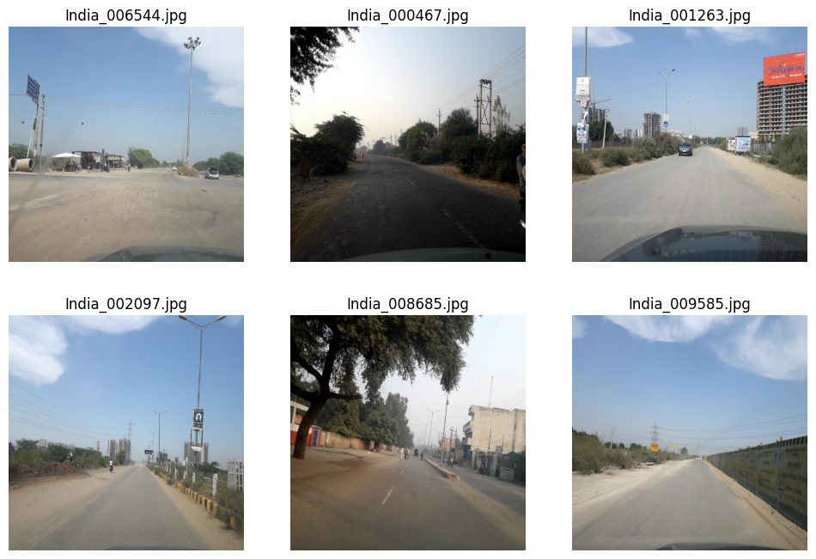
Fig 1. Samples from dataset

4.3 Class Distribution and Imbalance
A total of approximately 9,531 annotated bounding boxes were counted across all 7,706 images. The distribution across damage classes is as follows:

Code | Damage Type | Count | Percentage
D40 | Pothole (Holes/depressions in pavement) | 3187 | 38.85%
D44 | White Line Blur (Faded lane markings) | 1062 | 12.95%
D00 | Longitudinal Crack (Linear cracks parallel to road direction) | 1555 | 18.96%
D20 | Alligator/Crocodile Crack (Interconnected cracks forming patterns) | 2021 | 24.64%
D01 | Longitudinal Crack (Sealed/Repaired) | 179 | 2.18%
D11 | Transverse Crack (Sealed/Repaired) | 45 | 0.55%
D10 | Transverse Crack (Linear cracks perpendicular to road direction) | 68 | 0.83%
D50 | Other damage types | 28 | 0.34%
D43 | Cross Walk Blur (Faded crosswalk markings) | 57 | 0.69%
D0w0 | Longitudinal Crack (Wheelmark - rare variant) | 1 | 0.01%

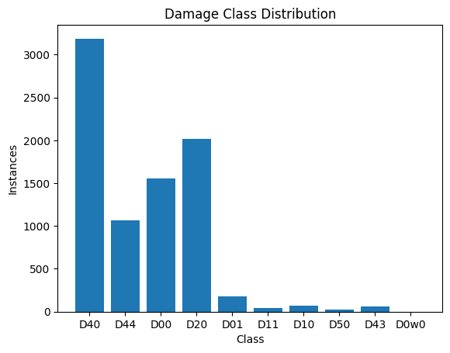
Fig 2. Damage Class Distribution

The data shows a significant class imbalance. Potholes (D40) make up the largest share of annotations, while transverse cracks (D10) account for less than 1% of all instances with only 68 examples. If left unaddressed, this imbalance could cause the model to become biased toward predicting potholes and largely ignore rarer damage types like D10.

4.3 Bounding Box Area Distribution
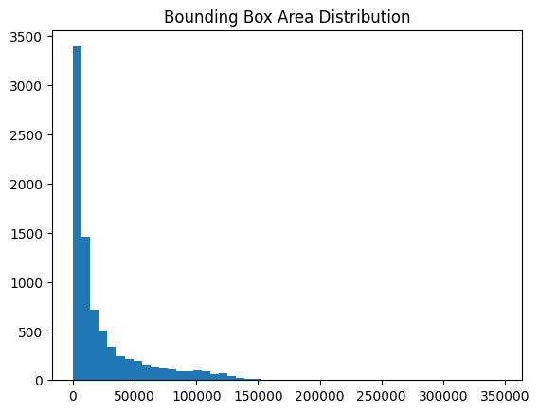
Fig 3. Distribution of Bounding Box Area

The bounding box area distribution is a critical metric for understanding the scale of road damage instances and the complexity of the detection task. Based on the analysis of the provided histogram:
- Heavily Right-Skewed Distribution: The data follows a "long-tail" distribution. This indicates that while a few damage instances are very large, the vast majority are relatively small compared to the total image resolution.
- High Frequency of Small Objects: The most significant peak is in the first bin containing nearly 3,500 instances.
- Sparsity of Large Damage Zones: Bounding boxes with large areas exceeding 150,000 pixel² are extremely rare. These larger boxes typically represent extensive alligator cracking or damage located directly in front of the vehicle-mounted camera.

5. Preprocessing and Augmentation Pipeline

5.1. Augmentation Strategy
To address the class imbalance identified in the EDA, an augmentation pipeline was designed using the Albumentations library. The pipeline is configured to preserve bounding box coordinates in YOLO's normalised xywh format throughout all transformations.

The planned augmentation techniques include:

- Geometric transforms: Random rotation (±15–30°), horizontal flipping, scaling, and shifting
- Colour and lighting adjustments: Brightness, contrast, hue, and saturation variations
- Weather simulation: Mild fog, rain, and blur effects to improve model robustness
- Class-aware augmentation: D10 instances receive 5–10× more augmentation passes; D00 and D20 receive 2–3× more, directly compensating for their lower representation in the dataset

5.2. Addressing Class Imbalance
The dataset shows extreme class imbalance with “Transverse Crack D10” class forming a tiny percentage 0.7% while “Potholes D40” makes up about 33.4%.

We will address these issues using a combination of strategies that includes:

- Focal Loss Optimization: We utilize YOLO’s native Focal Loss to automatically reduce the relative loss for well-classified "easy" examples (like Potholes) and focus the model's learning effort on "hard" minority classes like Transverse Cracks.
- Mosaic Data Augmentation: We employ Mosaic augmentation to tile multiple training images together, which forces the model to identify rare damage types across a much wider variety of scales and lighting conditions within every training batch.
- Class-Specific Oversampling: We can manually increase the representation of minority classes by duplicating images containing rare damage or applying synthetic transformations such as flipping and rotation specifically to those underrepresented samples.
- Weighted Loss Functions: We assign a higher mathematical "penalty" to errors made on minority classes based on their inverse frequency, ensuring our model prioritizes accuracy for rare damage types during the backpropagation process.
We also merged small minorities based on similarities:
- Multiple raw crack labels are merged into broader categories using a mapping dictionary (CLASS_MAPPING).
- Labels D00, D01, and D0w0 are merged into the class Longitudinal to represent longitudinal cracks.
- Labels D10 and D11 are merged into the class Transverse to represent transverse cracks.
- Label D20 is mapped to Alligator cracks.
- Label D40 is mapped to Pothole defects.
- Any label not present in the mapping dictionary is automatically assigned to the Others class.
- During processing, each bounding box label from the annotations is converted to its mapped class before counting.
- A class distribution summary is generated after mapping, showing the number of instances for each merged class.
- This reduces label fragmentation and simplifies the dataset into five final classes: Longitudinal, Transverse, Alligator, Pothole, and Others.

5.3. Addressing Leakage Concerns
We will be splitting our dataset into train and validation sets. We will be doing this using a stratified-spilt strategy made before any augmentation applied. Thus, mitigating any such concerns.

6. Sample Visualization
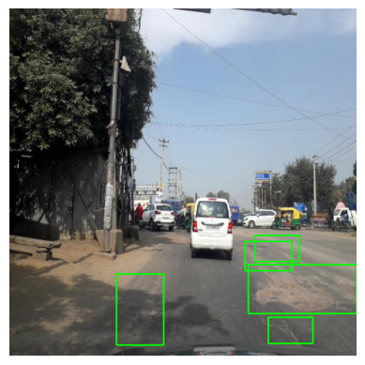
Fig 4. A multi-layered neural network visualization illustrating the hierarchical processing of visual features from a car image, where successive layers extract increasingly abstract representations.

7. Team Consent

Name | Roll No. | Sign
Yash Kumar | 22F3000472 | Y.K
Nishant Kumar | 22f3003042 | N.K
Rahul Yadav | 22F1001680 | R.Y
Neeraj Yadav | 21F1005729 | N.J
Kisalay Pan | 22F2001094 | K.P

References
- Arya, Deeksha & Maeda, Hiroya & Ghosh, Sanjay & Toshniwal, Durga & Sekimoto, Yoshihide. (2022). RDD2022: A multi-national image dataset for automatic Road Damage Detection. 10.48550/arXiv.2209.08538.

